1. Consider 4 modulation scheme：QPSK、offset QPSK、π/4-DQPSK、CPM

1. Show the possible phase trajectory for each scheme?
2. Compare these schemes in the viewpoint of the linearity and dynamic range requirements of a power amplifier.
3. Compare these schemes in the viewpoint of carrier phase synchronization for demodulation (coherent/non-coherent) in wireless propagation environments.
4. Compare these schemes in the viewpoint of symbol-interval synchronization at a receiver.
5. If high-order modulation schemes, such as 16-QAM and 64-QAM, are used for improving bandwidth efficiency, what additional information is required at a receiver for fading channels? Why?

Ans：

1. 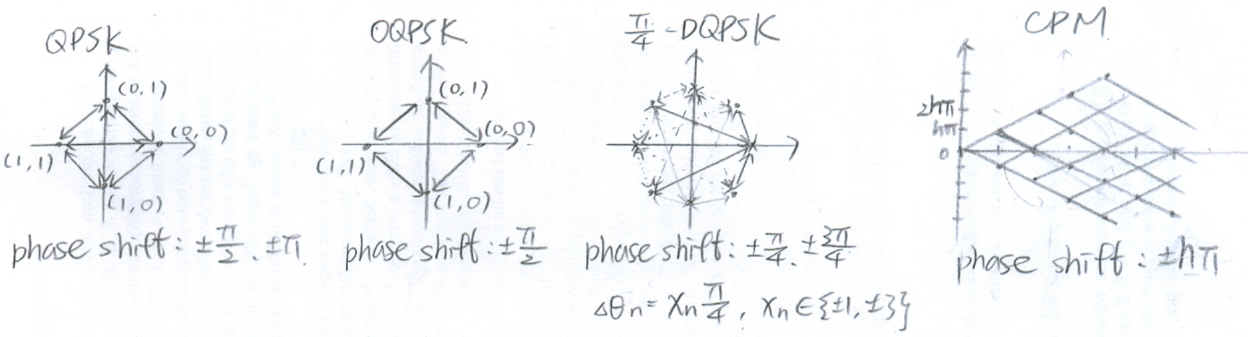
2. 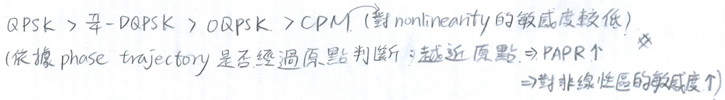
3. 因為QPSK和offset QPSK是以各個不同的相位作為symbol，所以需要參考相位才能做同步（coherent）。

而π/4-DQPSK和CPM是以相位差來決定symbol，所以不需要參考相位即可做同步（non-coherent）。

1. QPSK、offset QPSK：每過一個週期相位**不一定**會發生變化（如data連續相同），因此較難做symbol-interval synchronization。

π/4-DQPSK、CPM：每過一個週期相位一定會發生變化，因此較容易做symbol-interval synchronization。

1. 需要知道channel的gain和phase information。

1. 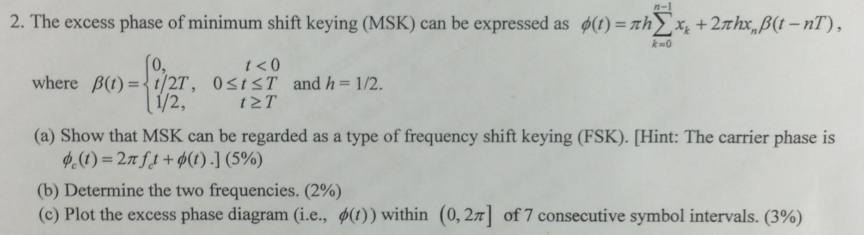
2. 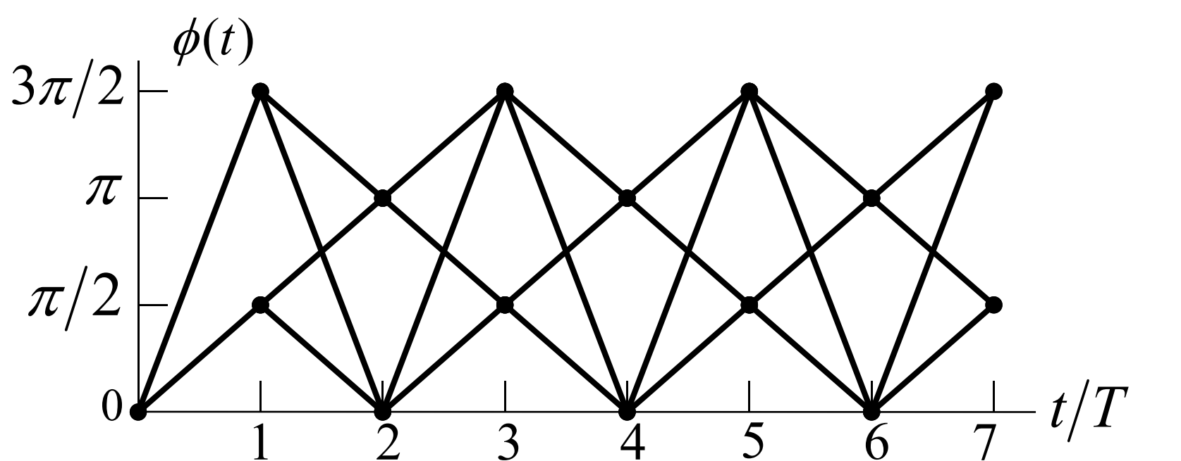 。

3.

1. Explain and compare (in the performance, complexity, required information, …) the 3 diversity combining techniques: SC, MRC and coherent EGC.
2. Assume that the bit error probability in the high SNR region can be expressed as $P_{b}∝β{\overline{γ}}_{c}^{-L}$, where $β$ and $L$ are constants and ${\overline{γ}}_{c}$ is the average received bit energy-to-noise ratio for each diversity branch. Derive the diversity order and illustrate the meaning of diversity order in a figure of $P_{b}$ versus ${\overline{γ}}_{c}$。
3. For a fixed number of diversity branches, does the diversity order depend on the applied diversity combining techniques (SC, EGC and MRC)? Why?

Ans：

1. 解釋：

SC：選擇SNR最高的branch。

MRC：將branch乘上各自的權重（根據channel fading gain），再做combine。

coherent EGC：將各branch平等的做combine（會做相位補償）。

比較：

performance：MRC > EGC > SC

complexity：MRC > EGC > SC

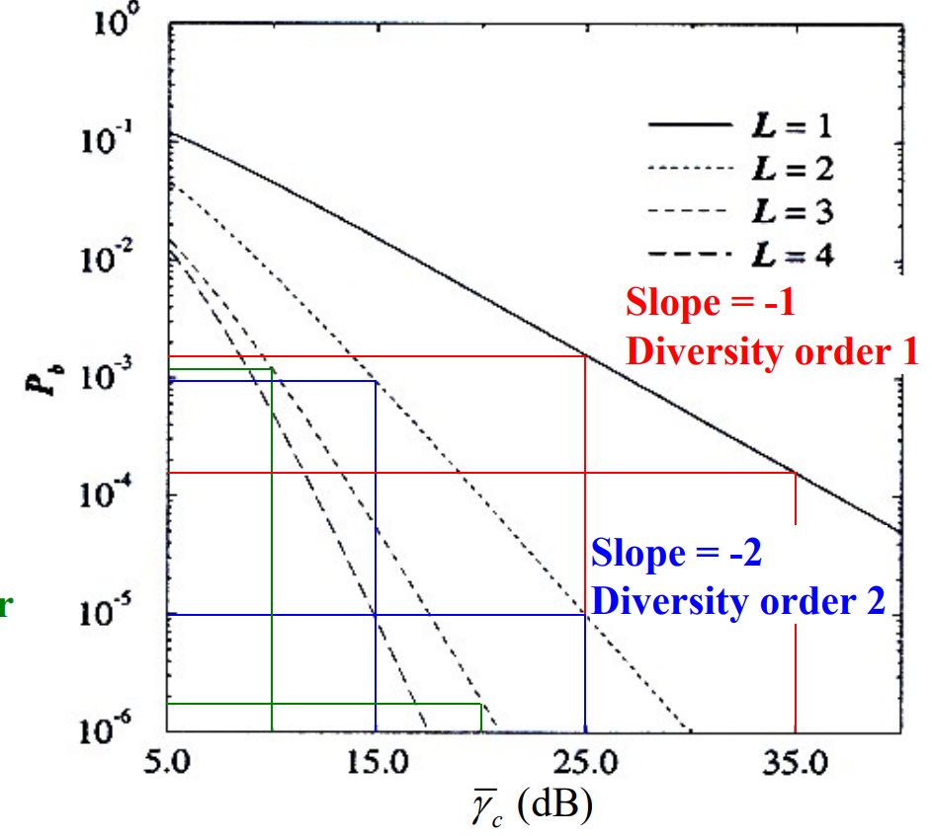required information：SC需要SNR、MRC需要gain跟phase、EGC需要phase。

$P_{b}∝β{\overline{γ}}_{c}^{-L}$

$⇒10\log{P_{b}}∝(10\log{β}-L⋅10\log{{\overline{γ}}_{c}})$。

*L*為diversity order。

圖的斜率為 $-L$。

1. No. 由上題算式可知，diversity order跟combining techniques無關，只跟diversity branches的數量有關。而combining techniques只和 $β$、 $P_{b}$ 有關。

4.

Show that the performance of the 2×2 (兩個傳送天線兩個接收天線) space-time transmit diversity scheme is equivalent to the MRC scheme with the number of diversity branches $L=4$. [Hint: The symbol pairs transmitted from antennas 1 and 2 in two contiguous baud periods are $({\tilde{s}}_{\left(1\right)}, {\tilde{s}}_{\left(2\right)})$ and $(-{\tilde{s}}_{(2)}^{*}, {\tilde{s}}_{(1)}^{*})$. The corresponding channel gains are $g_{11}, g_{12}, g_{21}, g_{22}$.]

Ans：

先列出received signals，再算出 ${ \tilde{v}}_{\left(1\right)}, { \tilde{v}}_{\left(2\right)}$。可列出MRC的式子。得證equal。

5.

To improve system performance, each cell can be divided into an inner cell and an outer cell by using reuse partitioning. Channels are assigned to the inner and outer cells according to 4-cell and 7-cell frequency reuse plans, respectively. The radius of the outer cell is assumed to be $R_{o}$.

1. Find the maximum acceptable radius $R_{i}$ of the inner cells.
2. According to the result obtained in (a), if the traffic distribution is homogenous, find the percentages of the channel numbers assigned to the inner-cell set and the outer-cell set.
3. Find the capacity improvement when compared with the original system using the 7-cell frequency reuse plan.

Ans：

1. $D_{o}=\sqrt{3N}R_{o}=\sqrt{21}R_{o}、D_{i}=\sqrt{21}R_{i}⟹R_{i}=\frac{D_{i}}{ \sqrt{21} }=\frac{\sqrt{12}⋅R_{o}}{ \sqrt{21} }=\frac{2}{ \sqrt{7} } R_{o}$。

可背 $R_{i}=\frac{ \sqrt{3⋅4} }{ \sqrt{3⋅7} } R_{o}$。

1. $R_{i}=\frac{2}{ \sqrt{7} } R_{o}⟹A_{i}=\frac{4}{ 7 } A_{o}⟹$ channel numbers $N_{i}:N_{o}=\frac{4}{ 7 }:\frac{3}{ 7 }=4:3$。
2. total channel number $N_{T}=\left(\frac{4}{ 7 }⋅4+\frac{3}{ 7 }⋅7\right)N_{c}={\frac{ 37 }{ 7 }N}_{c}$

only 7-cell： $N_{T}=7 {N_{c}}^{'}$

capacity improvement： $\frac{ N_{c}-{N_{c}}^{'} }{{N_{c}}^{'}}=\frac{\frac{ 7 }{ 37 }N_{T} - \frac{1}{ 7 }N_{T}}{ \frac{1}{ 7 }N_{T}}=\frac{12}{ 37 }$

6.

1. Explain why cell sectoring can improve the worst case carrier-to-interference ration (CIR) in comparison with the omni-directional cell planning.
2. Determine the disadvantages of applying cell sectoring.
3. Assume that multiple narrow beam antennas are used at base stations. Determine the channel assignment (usage) when trunkpool techniques (sector-trunkpool and omni-trunkpool) are applied.
4. Determine the advantages/disadvantages of using trunkpool techniques.

Ans：

1. 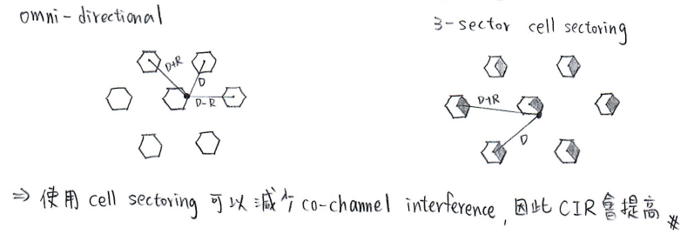 。
2. 1.每個cell需要更多天線 $⇒$ 成本提高

2.促使更多inter-sector handofff $⇒$ higher system loading

3.降低trunking efficiency

1. sector-trunkpool：若MS在同一個sector中移動時，不需做handoff；若MS從一個sector移動到另一個sector，則需要做handoff。

omni-trunkpool：MS可以使用cell中的channels，MS在同一個cell中移動時，不用做handoff。

1. 優點：增加trunking efficiency $⇒$ blocking rate降低

缺點：強迫中止通話的機率提高

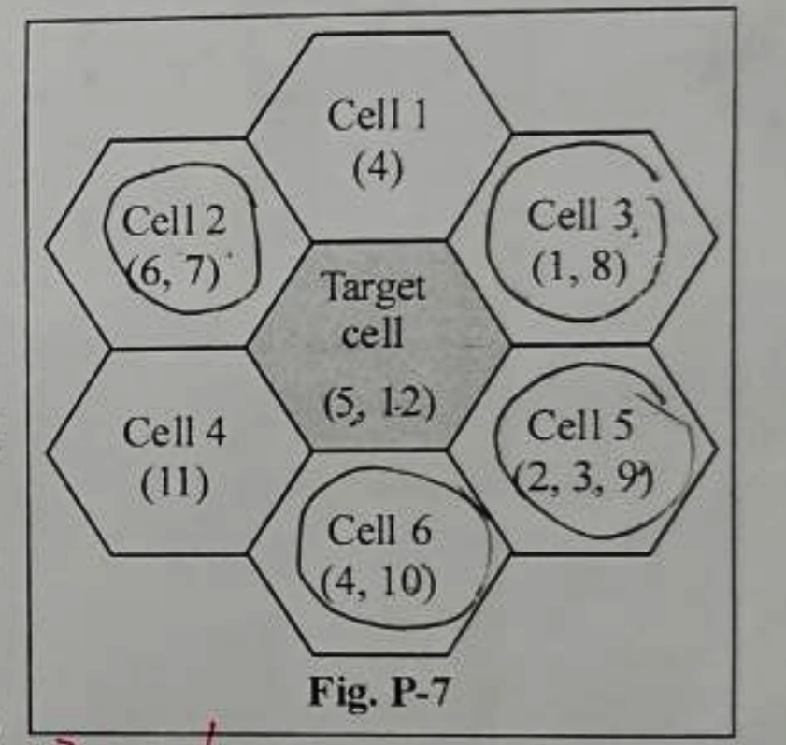7. Consider 7-cell system with aa 4-cell frequency reuse plan. There are a total of 12 channels available, and the channel numbers used in the cells are shown in the figure.

1. Assume that system-wide channel information is available, and that channel rearrangements in all cells can be performed (i.e., the centralized DCA-maximum packing scheme). How many additional users can be accommodated in the target cell?
2. According to the result obtained in (a), find a feasible channel assignment for all cells to accommodate the users.
3. According to the result in (b), if a user in **Cell 3** terminates its call, how many additional users can be accommodated in the target cell? Why?
4. According to the result in (b), if a user in **Cell 2** terminates its call, how many additional users can be accommodated in the target cell? Why?

Ans：

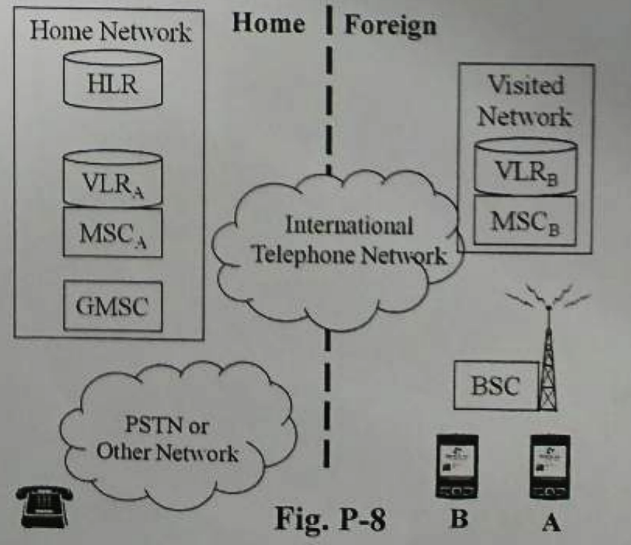8. Consider 2 roaming users, **A** and **B**, travelling outside the geographical coverage area of the home network, as shown in the figure.

1. Determine the telephone traffic routing for a mobile originating call from user **A** to the wired telephone.
2. Determine the telephone traffic routing for a mobile originating call from the wired telephone user **A**.
3. Determine the telephone traffic routing for a mobile originating call between the users **A** and **B**.

Ans: 手畫

9. Show that the average symbol energy-to-noise ratio with MRC is $γ_{s}^{MR}=\sum_{k=1}^{L}{γ_{k}}$, where $γ_{k}$ is the

average symbol energy-to-noise of the *k*-th branch and L is the number of diversity branches. [Hint: The channel-gain envelope of the composite signal is $α_{C}=\sum_{k=1}^{L}{{α_{k}}^{2}}$, and $γ_{s}^{MR}={α_{C}}^{2}E_{av}/σ_{\tilde{n}, tot}^{2}$.]

Ans：手算到熟。

10. Explain in detail the following random access protocols:

1. Pure ALOHA protocols.
2. Slotted ALOHA protocols.
3. *p*-persistent Carrier Sense Multiple Access (CSMA) protocol.
4. Non-persistent CSMA protocol.

Ans：要記圖

1. User可隨時傳送，當collision發生時，user要等一個random backoff time後再傳。
2. User要傳送時，一定要在每個time slot的開端傳送。當collision發生時，user要等一個random backoff time後，在下一個time slot的開端傳送。
3. 當user要傳送時，會先看有沒有其他人在傳。如果有，則等到通道空閒後，有*p*的機率傳送、 $1-p$ 的機率再等一個random backoff time。
4. 當user要傳送時，會先看有沒有其他人在傳。如果有，會直接再等一個random backoff time。

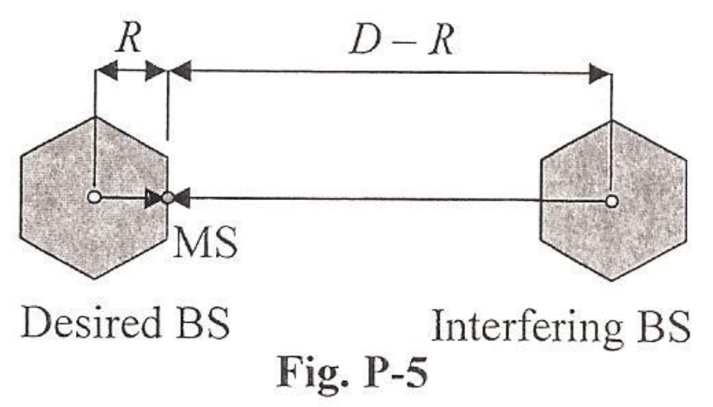11. Considering a cell with only one co-channel cell, the average received signal power from base station at distance *d* can be expressed as $μ_{Ω(d)}=μ_{Ω(d_{0})}-10β\log{(d/d_{0})}$, where $μ_{Ω(d_{0})}$ is the average received power (in dBm) at a reference distance $d_{0}$, and $β$ is the path loss exponent. The standard deviation of the received signal power caused by shadowing is assumed to be $σ_{Ω}$。

1. Determine the worst case average received carrier-to-interference power ratio (CIR) (in dB) as a function of *R*, *D* and $β$.
2. If the desired CIR threshold is $Λ_{th}$ (in dB), determine the worst case CIR outage probability.
3. If the CIR margin required for sustaining a specific CIR outage probability is $M_{Λ}$ (in dB), determine the frequency reuse factor *N*.[Hint: $D/R=\sqrt{3N}$, and the CIR outage is .]

Ans：

12. Consider the handoff mechanisms for mobile cellular systems.

1. Compare and explain the NCHO, MAHO and MCHO handoff mechanisms.
2. Propose (with detailed explanation) two possible schemes that adopt handoff priority to reduce the probability of forced termination.

Ans：

1. NCHO：Network Controlled Handoff
2. Serving cell會監測MS是否在boundary。
3. 鄰近的cell也會監測MS，並將資料回傳給Network。
4. Network controller會找出最佳的serving cell和frequency channel。

MAHO：Mobile Assisted Handoff

1. MS會監測鄰近的cell，然後回傳至serving cell，再由serving cell回傳至network controller。
2. Serving cell監測MS是否在boundary。
3. Network controller找出最佳的serving cell和frequency channel。

MCHO：Mobile Controlled Handoff

1. MS主動監測鄰近的cell，尋找比現在的serving cell品質更好的cell。
2. MS選擇一個新的frequency channel並access到cell。
3. 新的serving cell接受MS並通知舊的serving cell可以終止和MS之間的link。

比較：

NCHO是由BS去監測，而MAHO跟MCHO是由MS去監測。NCHO跟MAHO是由network controller做決定，MCHO則是由MS自行做決定。

NCHO：當reuse factor較小時，可能發生錯誤。

MAHO：因為MS只有一個transceiver，無法同時保持通話與監測。因此不適用於FDMA。

MCHO：MS的功能較強，因此network不需要太強。

1. –Guard channel：保留一些channel專門給handoff requests

–Handoff queuing：如果沒有channel來handoff，則handoff request會在target cell等，等到有channel可用。等的同時MS和serving cell會維持link。

13. Considering a macrocellular system, the required forward link carrier-to-interference ratio is $Λ_{th}≥10$ dB and the path loss model is assumed to be $L\left(d\right)=L\left(d_{0}\right)-40\log_{10}{(d/d_{0})}$.

1. Find the smallest allowable frequency reuse factor for the omni-cell configuration.
2. Find the smallest allowable frequency reuse factor for the 3-sector-cell configuration.
3. If an additional fading margin of 6 dB is required, find the smallest allowable frequency reuse factors for the omni-cell configuration and the 3-sector-cell configuration.

[Hint: Omni-cell $Λ=\frac{1/2}{ {\left(\frac{D}{ R } - 1\right)}^{-β}+ {\left(\frac{D}{ R }\right)}^{-β}+ {\left(\frac{D}{ R }+ 1\right)}^{-β} }$, 3-sector-cell ; ,、.]

Ans：

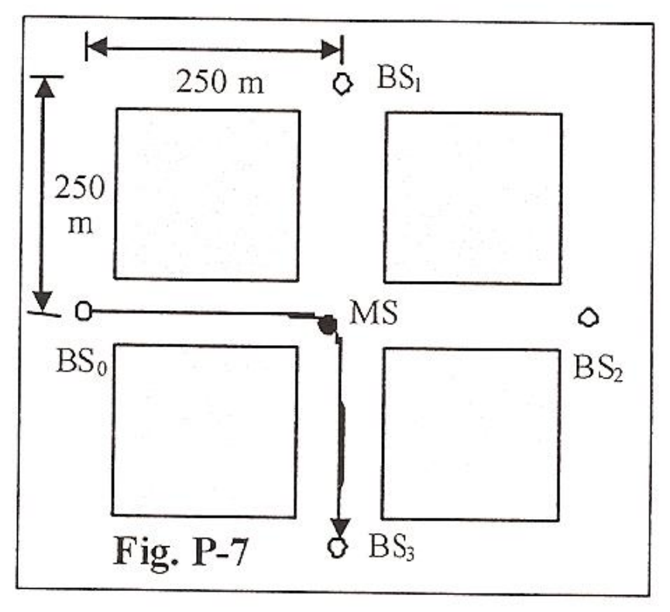

15. As shown in the figure, a mobile station is traveling from $BS_{0}$ to $BS_{3}$.

1. Illustrate the received signal strength (in dBm) coming from those four BSs versus the MS traveling distance from 0 to 500 m. Explain the reason in detail.
2. Explain and compare the RSS-based and CIR-based handoff algorithms in detail.

Ans：

1. 要背圖。

0 ~ 250m：BS1和BS3在一開始會有corner effect，因此強度較弱，隨著慢慢移動強度會越來越高。因為離BS0越來越遠所以強度降低、離BS2越來越近所以強度變高。

250 ~ 500m：BS0和BS2會有corner effect因此強度降低。因為離BS1越來越遠所以強度降低、離BS3越來越近所以強度變高。

1. $RSS=C+I+N$ 包含carrier、interference、noise，RSS大不一定代表訊號強度較強，因此不易判斷link性能。

$CIR=\frac{C}{ I+N }$ 是看carrier和interference + noise的比例，因此判斷上較準確。

比較：RSS較簡單但不準，CIR較複雜但準確。

16. If desired handoff cannot be applied, two schemes were proposed for achieving handoff priority to reduce the probability of forced termination.

1. Explain the two schemes in detail.
2. What is the impact on system performance when the two schemes are applied?

Ans：

1. –Guard channel：保留一些channel專門給handoff requests

–Handoff queuing：如果沒有channel來handoff，則handoff request會在target cell等，等到有channel可用。等的同時MS和serving cell會維持link。

1. 因為分出了一些channels給handoff使用，所以使得new call blocking rate增加。

17. Suppose that a binary sequence **x**, $x_{n}∈\left\{-1,+1\right\}$, is transmitted over an ISI channel with the channel gain vector $g=$ (1.5, 0.5, 1) and the initial state (-1, -1).

1. Illustrate the channel model by using a transversal filter.
2. Illustrate the state and trellis diagram for an MLSE receiver.
3. Explain the role of training sequences for MLSE receivers.
4. What is the impact of the training sequence length for TDMA mobile cellular systems (such as GSM systems)?

Ans：

1. 畫圖
2. 畫圖
3. training sequence：傳送接收端已知的sequence，讓接收端收到後可以進行通道估測。
4. training sequence越長，估測越準，但頻寬消耗越大。

training sequence越短，估測越不準，但節省頻寬。

18. Considering the two-branch switch and stay combing (SSC) scheme with two uncorrelated branches, the switching threshold is *T*, the average received bit energy-to-noise (ENR) is $p_{γ_{k}}\left(x\right)=\frac{1}{ {\overline{γ}}_{c} }e^{-x/{\overline{γ}}_{c} }.$

1. Determine the probability *q* that the received ENR in a specific branch is below the threshold *T*.
2. If the probability that the received ENR in a specific branch is below a value $S$ is $p$, determine the probability that the ENR at output of the switched combiner is below $S$, i.e. $\operatorname{Pr}{[ γ_{s}^{SW}≤S ]}$, for *S* < *T* and *ST*.

22.

23. 名詞解釋

1. Space diversity
2. Angle diversity
3. Polarization diversity
4. Frequency diversity
5. Field diversity
6. Multipath diversity
7. Time diversity

Ans：

1. Space diversity：利用多天線實現，通常天線要距離夠遠，讓相關性夠小以得到diversity。
2. Angle diversity：利用指向行天線實現，每個天線會選擇從narrow range of angle來的平面波。
3. Polarization diversity：利用極化方向不同來實現，scattering環境通常可以depolarize訊號。
4. Frequency diversity：利用多頻率通道來實現，channel間隔要大於channel的coherence bandwidth。
5. Field diversity：利用電場和磁場來實現，電場和磁場的components在任意一點都是不相關的。
6. Multipath diversity：以不同的delay來解析multipath component，因此time resolution需要夠高。
7. Time diversity：利用multiple time slots，time slot間隔至少要大於channel的coherence time。

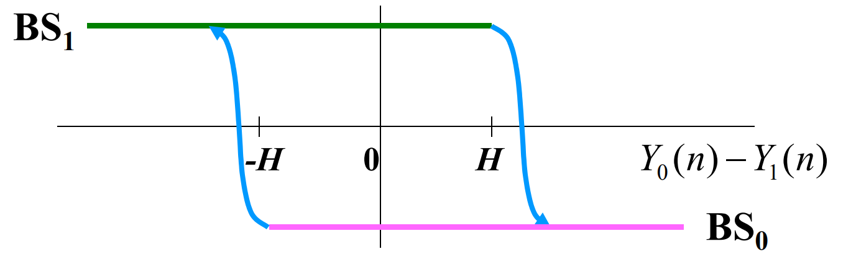24. Signal strength based Handoff algorithms.

H：hysteresis (dB)、 $Y_{0}\left(n\right) \& Y_{1}\left(n\right)：$ BS0與BS1的估測signal strength (dBm)。

$$\left\{\begin{aligned}Y_{1}\left(n\right)>Y_{0}\left(n\right)+H if the serving BS is {BS}_{0} \\ Y_{0}\left(n\right)>Y_{1}\left(n\right)+H if the serving BS is {BS}_{1}\end{aligned}\right.$$

2019、2020新題目：

25. Suppose that a binary sequence **x**, $x_{n}∈\left\{-1,+1\right\}$, is transmitted over an ISI channel with the channel gain vector $g=(g_{0}, g_{1}, g_{2})=$ (1.3, 0.7, 0.4) and the initial state (-1, -1).

1. Illustrate the state diagram and trellis diagram (until epoch 5) for an MLSE receiver.
2. Determine the desired receiving signal for each possible branch in the trellis diagram.
3. Determine all the branch metrics for the received signals 0.8 (1st symbol) and $-$ 1.3 (2nd symbol).

Ans：

1. 背圖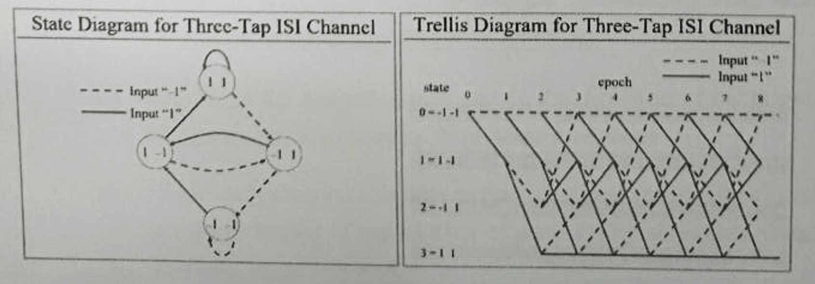
2. 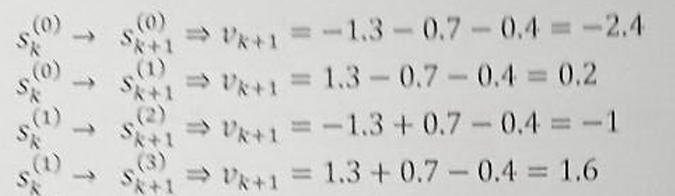手算
3. 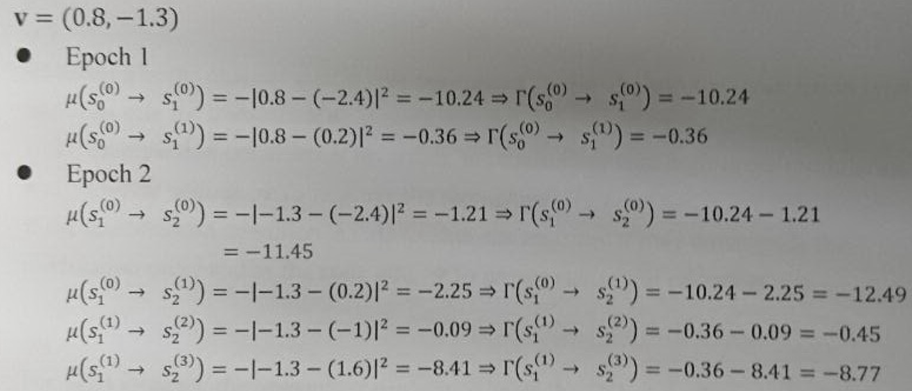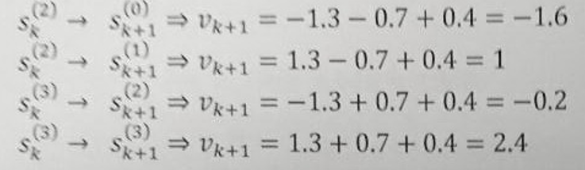手算。

26. The multi-antenna technique is used for performance improvement in wireless communications systems. The benefits of using multi-antenna systems include diversity, beamforming, and spatial multiplexing.

1. Which parameter determine the mutual correlation between the radio-channel fading experienced by the signals at different antennas? What condition achieves high (low) mutual fading correlation?
2. To achieve diversity gain, what is the requirement of antenna mutual fading correlation? Why?
3. What are the two main purposes of beamforming? [Hint: maximizing/minimizing what metrics]
4. Considering an antenna configuration consisting of $N_{T}$ transmit antennas and $N_{R}$ receive antennas, determine and explain the upper bound of the number of parallel signals that can be spatially multiplexed.

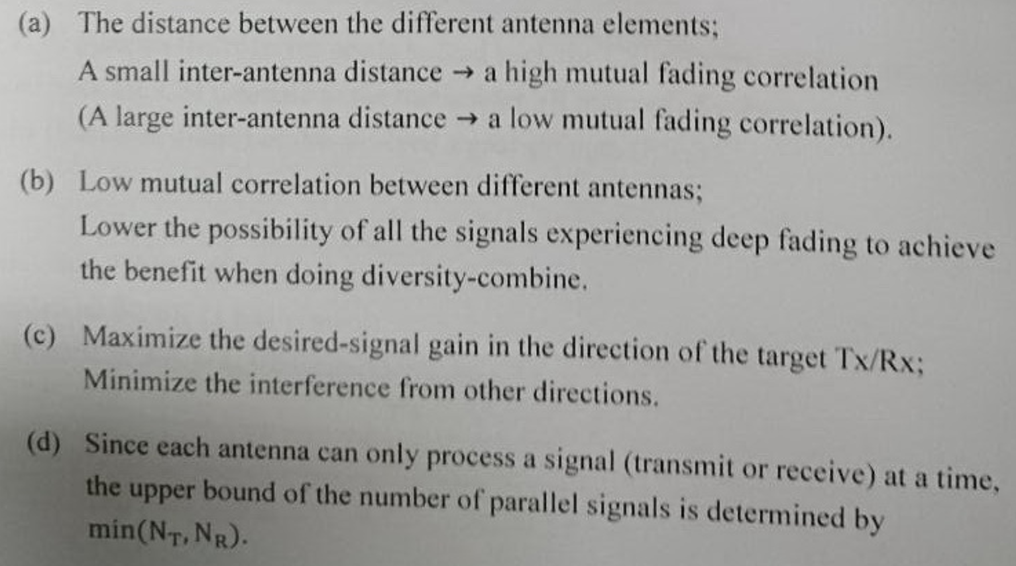Ans：

27. Link adaptation is a technique used to improve the transmission efficiency in wireless communications.

1. Explain in detail the link adaption mechanism by adapting both modulation and coding.
2. Link adaptation generally requires some channel state information (CSI) at the transmitter. Explain how to obtain the CSI for TDD systems and for FDD systems
3. If two modulation schemes GMSK and 8PSK (or QPSK and 16-QAM) are used and the available code rates are 1, 3/4, 2/3 and 1/2, show the applied modulation/coding and the corresponding throughput (information bits per transmitted (coded) symbol) in descending order with respect to the received SNR.

Ans：

1. 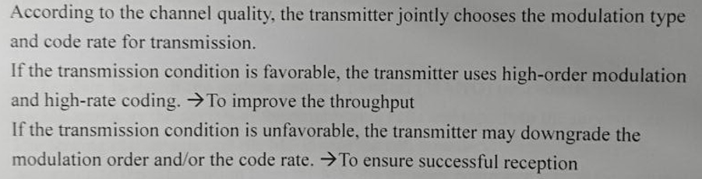
2. 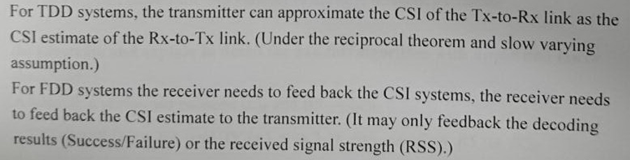
3. 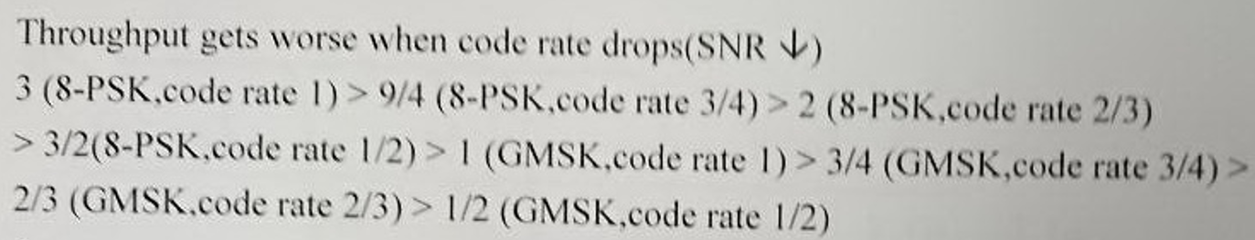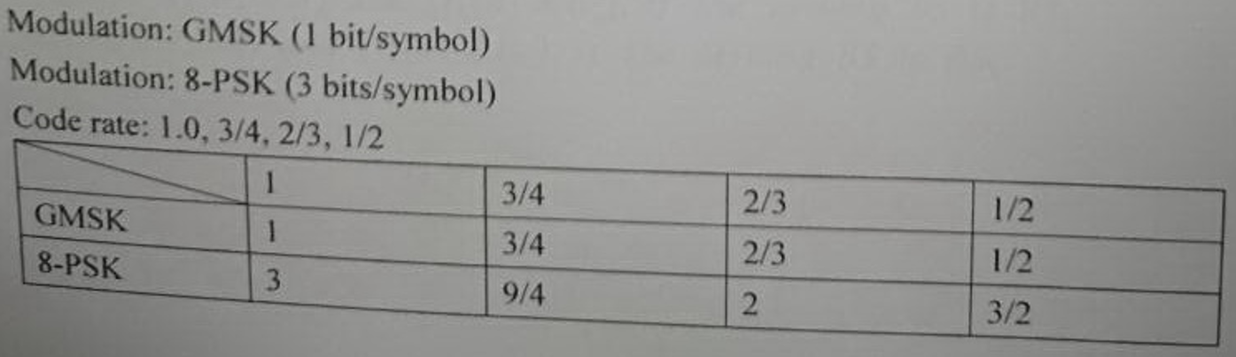

or

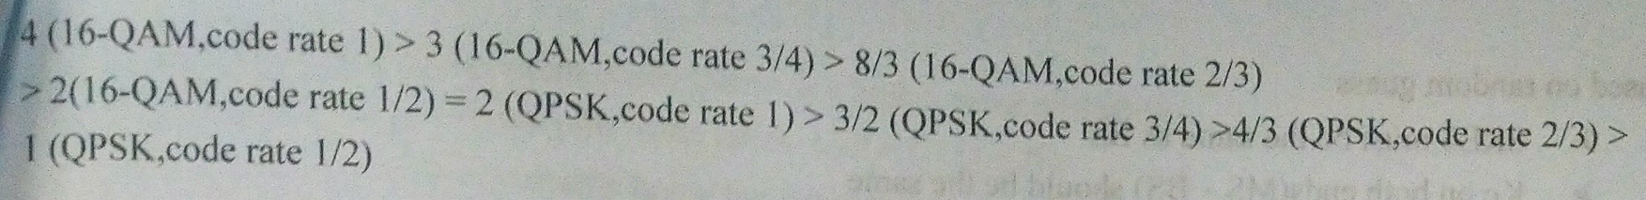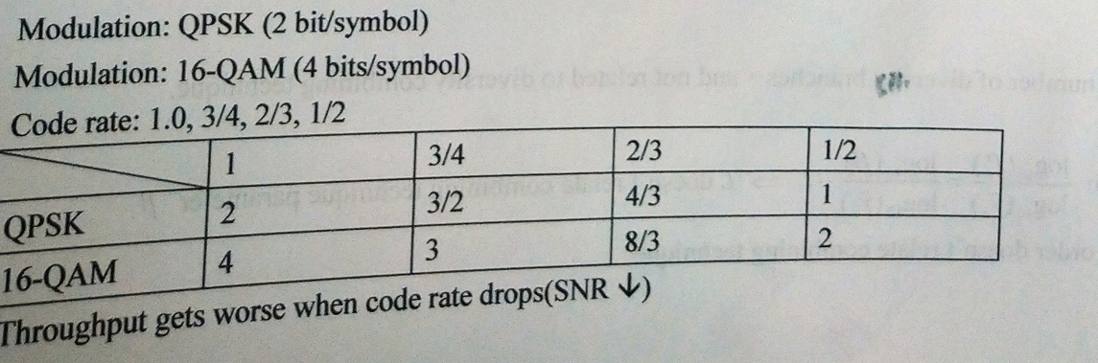

28. Assume that a mobile cellular system has the following system parameters. Find the maximum allowable path losses in the forward-link (downlink, from a base transceiver station to a mobile station) and reverse-link (uplink, from a mobile station to a base transceiver station).

**Tx power:** BTS = 50 dBm; MS = 30 dBm;

**RF loss:** BTS = 3 dB; **Body loss:** MS = $-$ 3 dB;

**Antenna gain:** BTS = 17 dBi; MS = $-$ 2 dBi;

**Margin:** Interference = 6 dB & Fading = 5 dB;

**Sensitivity:** BTS = $-$ 110 dBm; MS = $-$ 100 dBm;

**BTS Rx diversity gain:** 2 dB.

Ans：

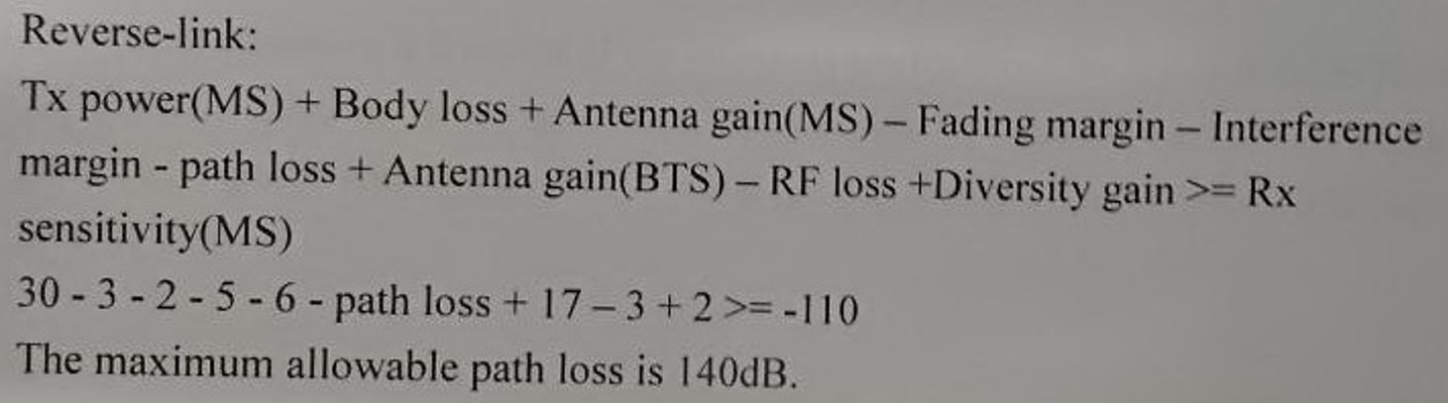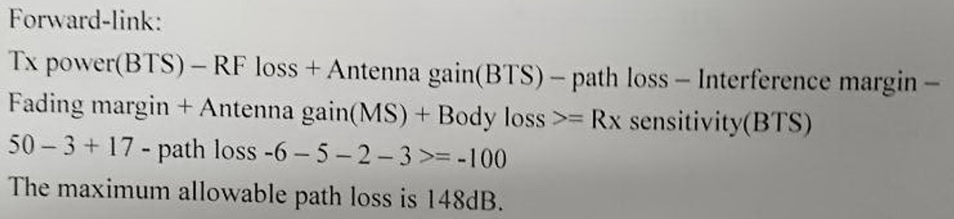

29. Assume that an MS is in the handoff region between BSQ and BS、with the received signal strength

being and respectively. For signal strength based handoff algorithms, the following parameters are applied: the original hysteresis *H*, the upper threshold $Ω_{U}$, and the lower threshold $Ω_{L}$.

1. Explain in detail the mobile assisted handoff (MAHO) procedure.
2. Illustrate and explain in detail the handoff algorithm with upper and lower thresholds, i.e., the conditions that the handoff will be performed.
3. Explain in detail why the hysteresis *H* is necessary.
4. Assume that directed handoff cannot be applied. Propose two possible schemes, with detailed explanation, to reduce the probability of forced termination

Ans：

1. MAHO：Mobile Assisted Handoff
2. MS會監測鄰近的cell，然後回傳至serving cell，再由serving cell回傳至network controller。
3. Serving cell監測MS是否在boundary。
4. Network controller找出最佳的serving cell和frequency channel。
5. 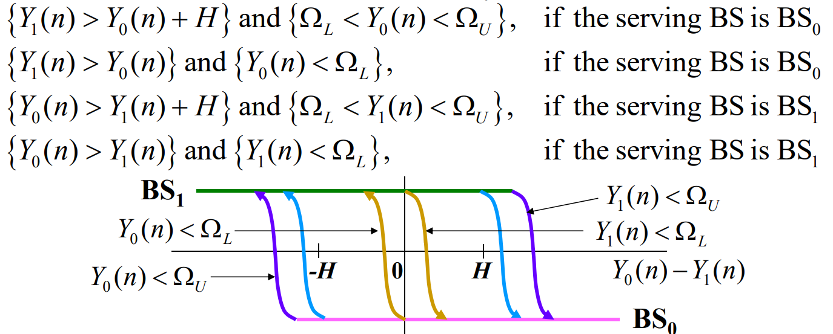
6. Hysteresis *H*是為了避免「在短時間內發生來回切換的情況」。
7. –Guard channel：保留一些channel專門給handoff requests

–Handoff queuing：如果沒有channel來handoff，則handoff request會在target cell等，等到有channel可用。等的同時MS和serving cell會維持link。

30. Considering the security issue in mobile communications, multiple hash algorithms are involved in user authentication and message privacy, such as A3 for authentication, A5 for message encryption and A8 for ciphering key generation.

1. Is it possible that different network operators use different hash algorithms? Evaluate the possibility and explain in detail the reason why for each hash algorithm.
2. In an authentication triplet, the lengths of RAND, SRES and Kc are 128 bits, 32 bits and 64 bits. Determine the probability that a fraud user can pass the authentication procedure based on random guess.
3. Determine the probability that a fraud user can pass the authentication procedure and correctly transmit/receive messages based on random guess.

[Hint: $2¹⁰ ≈10³$ and express your answer in the form $a×{10}^{-b}$ for $1<a<10$ and $b∈N$.]

Ans：

* Algorithm A3、A8
* Different hash algorithms can be used according to different network operators・
* Reason:

SIM card(A3、A8、Ki) and AuC/HLR(Ki) are issued by the network operators.

Hash algorithms can be set by the network operator.

* Algorithm A5
* Must be common to all GSM PLMNs and all mobile station(in particular, to allow roaming).

The hash algorithms must same all over the world.

1. 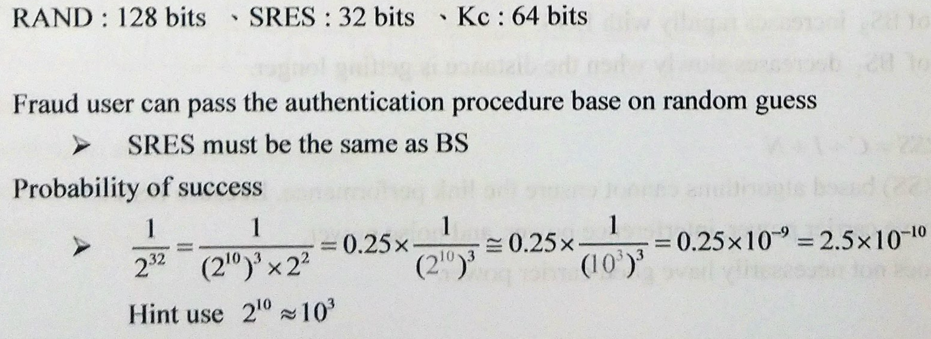
2. 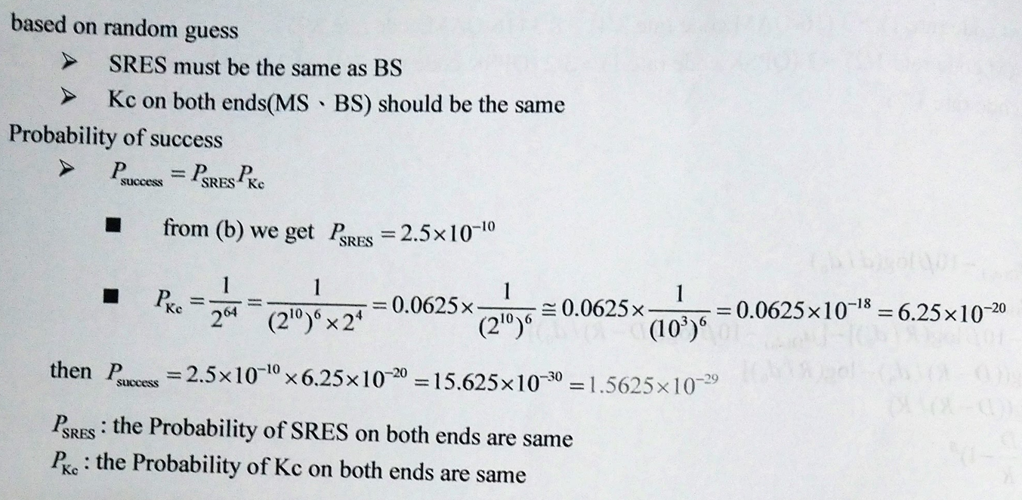Fraud user can pass the authentication procedure based on random guess and correctly transmit/receive message based on random guess